Computational Neuroscience Homework

HW3: Receptive Field

# Exercise 1) Making a model of receptive field in V1

## A) Normalize the constant C so that the sum of ON (positive) subregion of RF becomes 1. Plot the 2D image of the normalized RF(x,y). Use “colormap jet”, “axis xy image” and “colorbar” to indicate the scale of x, y and amplitude. Use this RF(x,y) for the following questions.

Here, for easier computation, resolution of the receptive field was selected as 1, and the receptive field was set as the equation below:

$$RF\left(x, y\right)=e^{-\left(x^{2}+y^{2}\right)/64}\cos{({πx}/{12}-π/2)}$$

However, the receptive field should be normalized, to make the sum of positive sub region to become 1. This should be achieved because $L^{i}$, what we set as the linear response of the neuron later on, needs to have a same scale no matter what the resolution of the receptive field is.

Finding the normalization coefficient can be achieved by simply extracting RF regions having positive value, and summing them up. To make the sum of the positive region 1, we can just decide the coefficient to be the reciprocal of the total sum of the RF positive region that we simply made previously. The result is plot below:

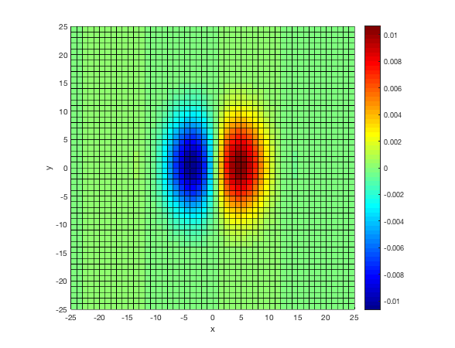

Figure . The result of ‘Prob1a.m’ code. The V1 receptive field is normalized.

## B) Create a “random checkerboard” visual stimulus S(x, y)=1 or -1, an image matrix of the same size as RF(x, y) where each pixel is filled with random binary numbers. Generate 5 samples stimuli and plot 2d image of them. Use “subplot” to show all of them in one figure.

We can easily generate a binary random number by using ‘round’ function with ‘rand’ function. The rand function generates random number between 0 and 1 in a uniform manner, so using round function on the value generated by rand function, we can gain 0 with the probability of 0.5, and 1 with the probability of 0.5. Now simply by multiplying 2 on this random number and subtracting 1, we always gain 1 or -1 (and the probability to gain 1 and -1 are equal). Using this idea, we can generate a random checkboard image as below:

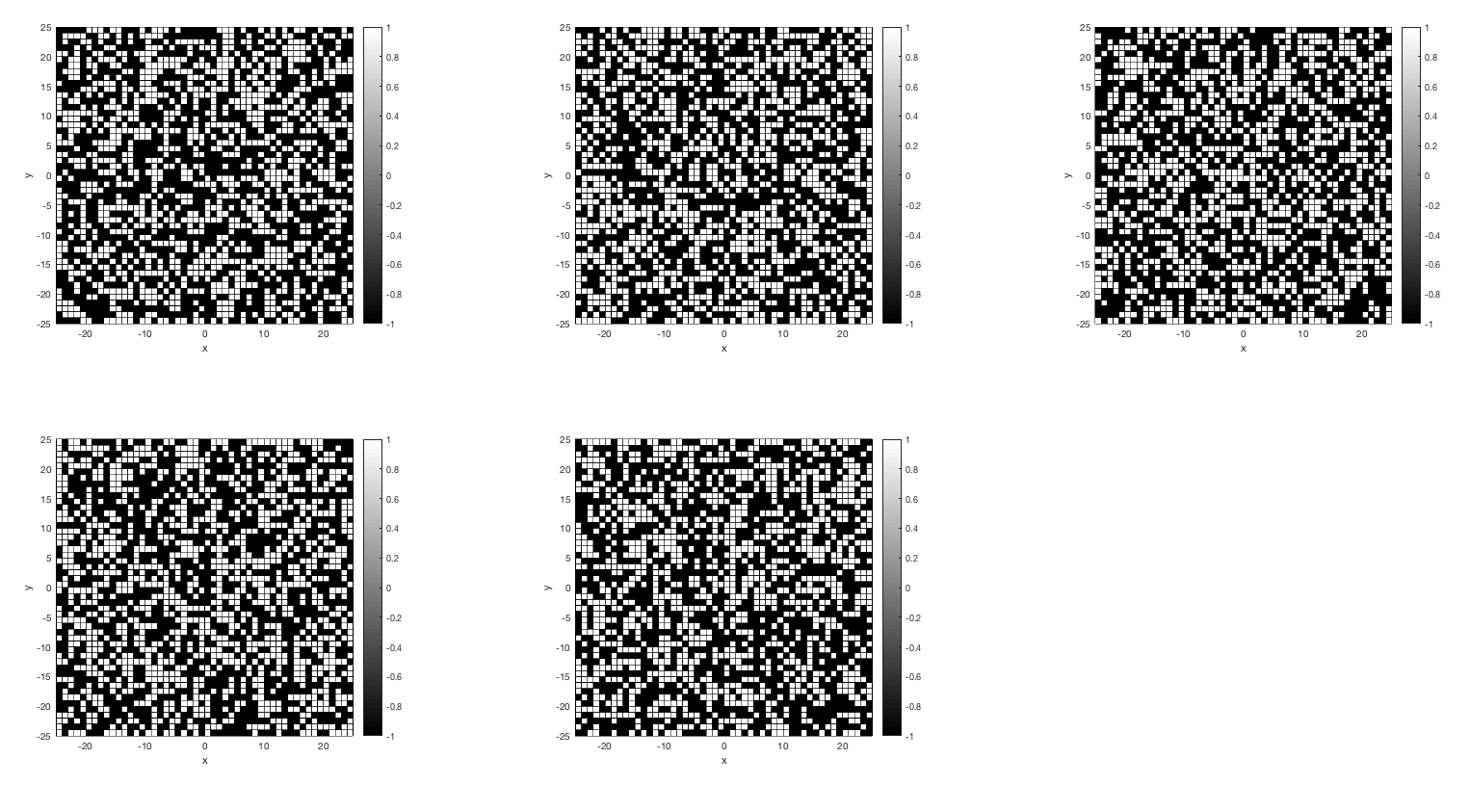

Figure . The execution result of ‘Prob1b.m’ code. Five different random cheakboards are generated.

## C) Assume the linear response of RF is given as

$$L=\sum_{x_{i}, { y}_{i}}{RF\left(x_{i},y_{i}\right)*S\left(x_{i},y_{i}\right)}$$

## In other word, L is the dot product of RF(x,y) and S(x,y). Plot the histogram of $L^{i, \left(i=1\sim 100\right)}$, the response of RF to 100 different S(x,y).

We can simply achieve this by calculating the dot product of the RF with the random checkboard for 100 times, and stack their calculation result in an array. The execution result is as below:

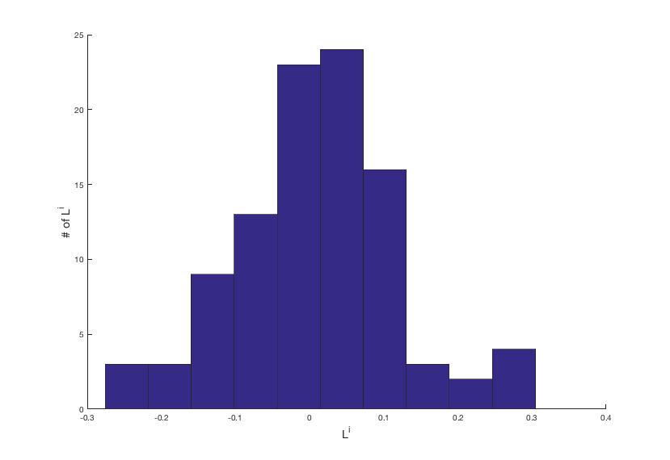

Figure . The execution result of ‘Prob1c.m’ code. The histogram of the $L^{i}$ shows that it is rare for the linear response to be over 0.1, which would be considered as the threshold in the upcoming problem set.

As shown in Figure 3, for most of the input stimulus the linear response value was approximately larger than -0.1, but approximately smaller than 0.1: the value was very close to 0, which means that most of the stimulus were a ‘neutralized’ stimulus. They were not enough for inducing a significant activation of V1 neuron. This is quite obvious result since the stimulus was just a random white noise. Linear responses exceed a certain value only when the white noise shows a similar pattern with the real receptive field by chance (at least a little, although it is almost impossible for a single white noise stimulus to represent the whole receptive field) , which occurs quite rare in random white noise stimulus.

## D) Now introduce a simple static nonlinearity

$$r\left(t\right)=r_{0}+F\left(L\left(t\right)\right), F\left(L\right)=200*{\left[L-0.1\right]}_{+}$$

## Where $r_{0}$ is randomly sampled from the positive part of a Gaussian distribution with mean=s.d.=1. Plot the histogram of firing rate of all samples, $r^{i, \left(i=1\sim 100\right)}$.

$r_{0}$ was selected from a Gaussian distribution, having both mean and standard deviation as 1. However, when the $r_{0}$ value is not a positive value, $r_{0}$ is re-obtained until it becomes a positive value. Using this approach, $r_{0}$ was chosen for each trial, and using the equation given in the question, the firing rate of 100 samples were collected. The below is the obtained histogram of firing rate of all samples:

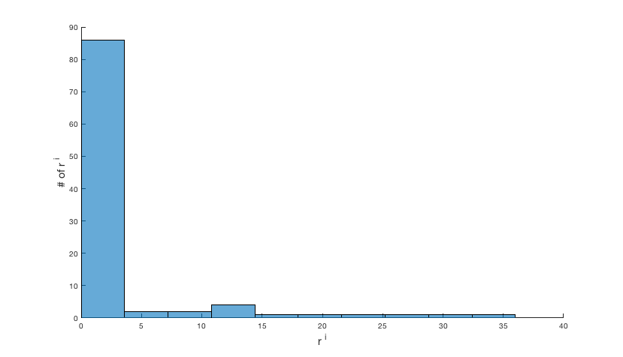

Figure 4. The execution result of ‘Prob1d.m’ code. The r histogram shows that for most samples the firing rate was approximately below 5Hz. Small proportion of samples tended to have a firing rate higher than 5Hz, and these are mostly the samples where the linear response exceeded the threshold.

## E) Make a scatter plot of “ $L^{i}$ vs. $r^{i}$” ($i$ =1~100). Discuss the condition that this model neuron can generate a spike.

Using the same code as in problem d, we just simply have to scatter plot the $L^{i}$ vs. $r^{i}$ graph. The plotted result is as below:

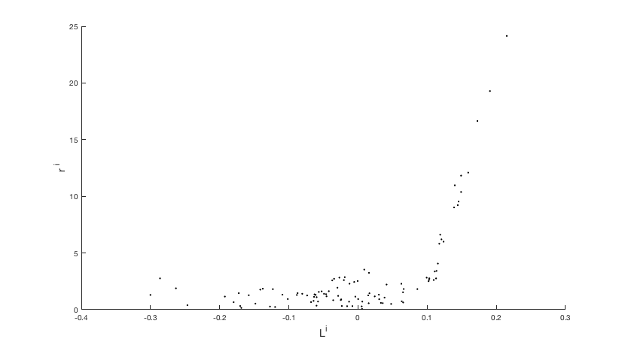

Figure 5. The $L^{i}$ vs. $r^{i}$ scatter plot. The firing rate increases linearly after the threshold, 0.1 in this case.

As we can confirm in Figure 5, the firing rate increases linearly after the threshold. So in the ideal case, (where no noise occurs), we can consider $L^{i}>0.1$ to be the case where spike is generated. However, in real neurons, due to the noise inputs or other conditions which cannot be controlled by the experimenter, the neuron’s firing rate might have some noise. Thus, we have to use a statistical tool to determine when exactly we can claim that the neuron generates a spike. Since we know that the null firing rate of the neuron follows a normal distribution with both mean and standard deviation as 1, we can say that

$$r_{0}\sim N_{mod}$$

where

$$N_{mod}=\frac{1}{\sqrt{2π}\left(1-Φ\left(1\right)\right)}e^{-{{\left(r-1\right)}^{2}}/{2 }} \left(for r>0\right)$$

$$N_{mod}=0 (otherwise:r≤0)$$

If we want to set the significant value as $α$, we need to find a threshold value $r_{t}$ where

$$\int_{r_{t}}^{∞}{\frac{1}{\sqrt{2π}\left(1-Φ\left(1\right)\right)}e^{-{(r-1)}/2}}dr=\frac{1}{\left(1-Φ\left(1\right)\right)}\int_{r_{t}-1}^{∞}{\frac{1}{\sqrt{2π}}e^{-{r^{'}}^{2}/2}dr^{'}}=\frac{1}{\left(1-Φ\left(1\right)\right)}Φ\left(1-r_{t}\right)$$

$$=\frac{Φ\left(1-r_{t}\right)}{Φ\left(-1\right)}=α$$

Let’s say that here we set $α=0.05$. Then, $Φ\left(1-r_{t}\right)=Φ\left(-1\right)α=0.158655…×0.05=0.00793…≅0.008$. Then, using z-score calculator, we can obtain that $1-r_{t}$ should approximately be -2.409. Thus, $r_{t}=3.409$, and thus if we approximately take $r_{t}=3.5$ Hz as the threshold value, with p-value smaller than 0.05, we can claim that the neuron generated a spike. (The firing rate cannot be explained with the random noise of the firing – this firing is rather dependent to the visual stimulus given to the receptive field.)

## F) Suggest your idea how to get your “reverse-correlated” reconstruction of the receptive field, using above result (You don’t need to make a code for this).

We can use both linear response ($L$) and firing rate ($r$) for reverse-correlated reconstruction of the receptive field. When we use linear response, we can set a threshold value of $L$, and then collect visual stimulus that has large enough linear response. (stimulus which has larger $L$ than the threshold: if you want to collect visual stimulus very strictly, you can simply increase the threshold value. However, this would lead to obtain fewer visual stimulus for reconstruction of the receptive field, so much longer – or larger amount of – stimulus would be required. In contrast, if we set the linear response to be too small, visual stimulus too much ‘dummy’ stimulus would be included, so that we would not be able predict the receptive field properly.) Then, since we know the linear response for each stimulus, we can give a weight to each selected visual stimulus. Imagine that the visual stimulus is so ideal that it is exactly the shape of the receptive field. Because we obtain 1 for the positive region, and another 1 for the negative region, the maximum linear response that we can get is 2. Thus, the receptive field can be calculated as

$$RF\left(x, y\right)=\frac{\sum_{i=1}^{N}{S_{i}\left(x, y\right)L_{i}/2 }}{N}$$

Using this idea, and setting the threshold value of the linear response as 0.1, we obtained the predicted receptive field as below:

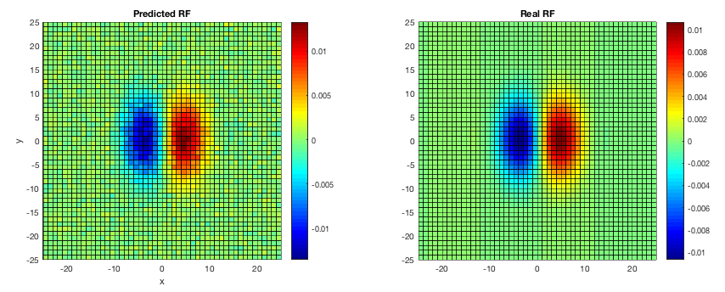

Figure 6. The predicted receptive field using the model described above. The shape, and also the scale is very close to the real receptive field. Thus, we can confidently claim that this model predicts the receptive field very well.

However, in reality, what we measure is the firing rate of the neuron: it is hard for us to obtain the linear response itself, so in reality, we have to select the visual stimulus in respect to the firing rate. In problem e, we have shown that firing rate over 3.5Hz were rejected to be a caused by a coincidence with a p-value less than 0.05, thus we can claim that visual stimulus which induce higher firing rate than 3.5Hz are ‘meaningful’. (Same as with the case using linear response, we can select a stricter value, such as 10Hz as the threshold. This would enable us to exclude ‘meaningless’ visual stimulus, (reduce the chance where the firing rate exceeds the threshold just by coincidence) but more visual stimulus should be then generated to obtain the same amount of meaningful stimulus.) Since we assume that we have no idea what the linear response is, (assuming that we don’t even know the relationship between linear response and the firing rate) what we can only do is to add those meaningful stimulus, and then normalizing it. The result is as below:

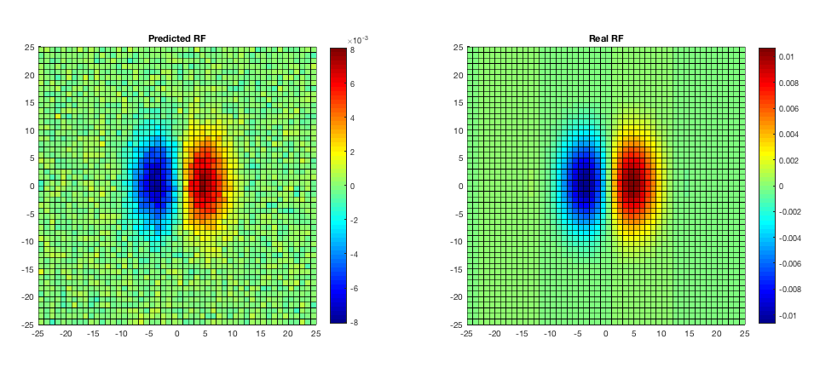

Figure 7. The predicted receptive field using the firing rate model. Although the receptive field is normalized, the result is not ‘exactly’ the same as with the real receptive field: the maximum and minimum value is slightly lower in the predicted receptive field. However, considering the fact that we did not use any prior knowledge about the receptive field, this prediction can be considered to be a very successful model.

Now, let’s assume that the linear response can be determined. Then, what would be the ‘time dependency’ of the visual stimulus to generate a spike? Should the linear response be a negative value 1ms before to have a better chance in generating a spike (does the spike generation also depend on time of the stimulus?) or is it independent from previous stimulus? To find out, the previous 99 linear responses and the linear response when a spike is generated (when the firing rate exceeds the threshold) were collected, and these 100-linear response train collected for each spike timing were averaged. The result is as below:

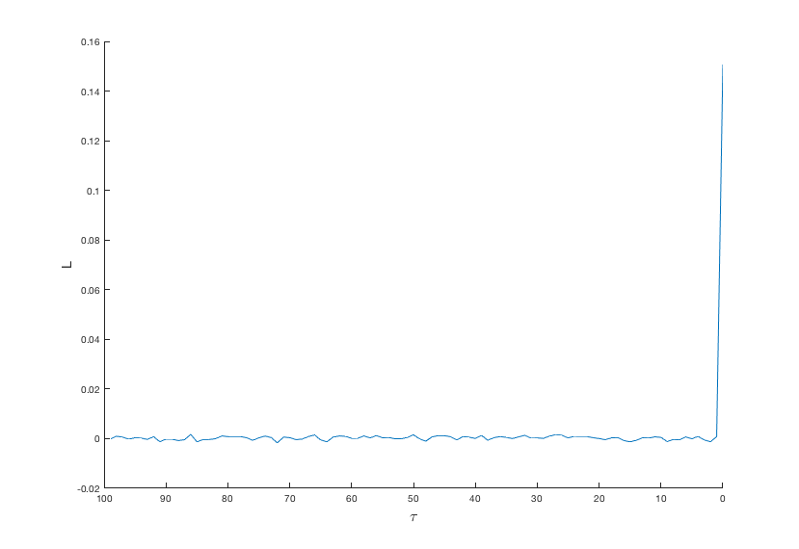

Figure 8. The average linear response for previous 99 stimuli and the stimulus which induced a spike. For all previous stimulus, the average linear response converged to 0, whereas the it was 0.16 in the stimulus that generates a spike, which is over the threshold value in the static nonlinearity firing rate model.

As shown in Figure 8, stimuli before the spike generation did not have any relation with generating a spike. The only stimulus that was correlated with generating a spike was the stimulus which directly caused a spike generation. This is actually an obvious result because we only considered the linear response in that moment to model the firing rate. (that’s why this is called a ‘static’ nonlinearity model!) However, by drawing the graph, we could confirm that this neuron is really a static model. In reality, most of the V1 receptive fields are reported to have a more complicated temporal structure.[1]

1. GC DeAngelis, *et al*., 1995, *Trends Neurosci*., 18(10):451-458.